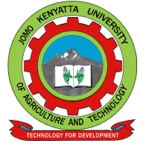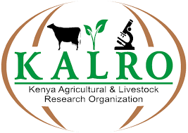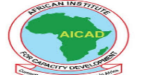

CALL FOR APPLICATIONS: PHD SCHOLARSHIP

The University of Nairobi and the University of Copenhagen recently received a grant from the Ministry of Foreign Affairs of Denmark within the Danida Fellowship Centre framework for the project entitled: "Adaptation to climate change to improve food safety and livelihoods among pastoral communities in Kenya (ADAPTiVE) ".

The Grant has provision for one (1) PhD scholarship within the area of anthropology, sociology or similar social sciences. The successful candidate must have successfully completed the 1st year of course work study at the Institute of Anthropology, Gender and African Studies (IAGAS), University of Nairobi. The scholarships will cover research cost, exchange programs and a living monthly stipend and are strictly tenable for three (3) years only.

ADAPTiVE is a collaborative research project jointly undertaken by Jomo Kenyatta University of Agriculture and Technology (JKUAT), University of Nairobi, Kenya Agricultural and Livestock Research Organization (KALRO), African Institute for Capacity Development (AICAD) and University of Copenhagen (UCPH). The project is funded by The Ministry of Foreign Affairs of Denmark and will be carried out between 2024 and 2029. The main objective is to investigate how to promote the adoption and sustained use of food safety strategies that are adapted to climate change, and thereby improve livelihoods in Africa through a combination of qualitative, quantitative, and experimental research methods, with a particular focus on women-led smallholder dairy farms in Kenya. The project has four core research themes but theme one below is the one of relevance to this call:
- Food safety hazards in the dairy sector in the face of climate change. This theme asks "how can climate change be expected to affect food safety performance and livelihoods of different actors in the Kenyan dairy sector?" The theme aims to map the most prevalent food safety problems from farm-to-fork in the Kenyan pastoral dairy sector and assess how these are influenced by climate change, whether value chain actors are aware of this and how livelihoods are impacted.
The PhD research topics will be centered on food safety hazards in the dairy sector in the face of climate change. The research carried out by the PhD candidate should provide new insights that contribute to improving food safety amid climate change.

Eligible candidates are invited to apply for the following available PhD scholarship.

Position: PhD in Anthropology

Qualifications:

- Candidates must have bachelor degree in
  - Bachelor of Arts in Anthropology, or
  - Bachelor of Arts Social Sciences
- Master’s degree
  - Master of Arts in Anthropology,
  - Master of Arts in Social Sciences,
  - Or similar
- Successful completion of PhD Course work/Year 1 of PhD studies
- Publications
  - Qualitative social science research
  - Policy briefs or others

Interested candidates who meet the criteria above are encouraged to send in their applications. Female applicants are particularly encouraged to apply.

To Apply:

Submit (upload):

- Cover letter/Motivation letter highlighting your suitability for the advertised position above
- Current Curriculum Vitae with contact information of 3 references (their name, email address, and phone number)
- Certified copies of your bachelor’s and master’s degree certificates, and transcripts.
- PhD enrollment and Grade report
- Two recommendation letters
- A Doctoral study synopsis (maximum 2 pages) related to the theme mentioned above. The concept note should include background, problem statement, objectives, and indicative methodology.

Submission to be made by 31st July 2024 to Director, IAGAS on email: iagas@uonbi.ac.ke, with cc to mha@ifro.ku.dk, as one complete PDF attachment.

Incomplete applications will not be considered. Please note that only shortlisted candidates will be contacted.

There will be no fee charges during the recruitment process.

